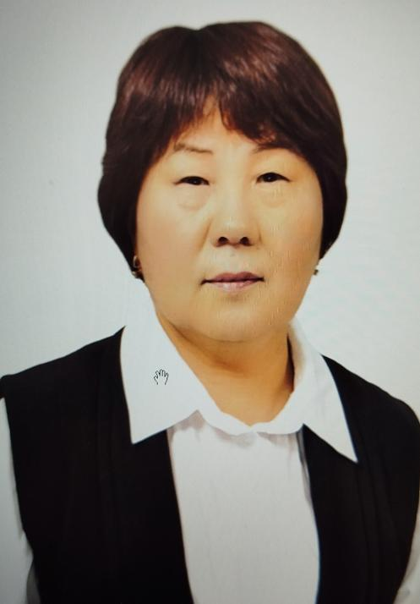
ИМАНКУЛОВА Майрамкуль Шалтаевна,
№4 Балжан Бөлтірікова атындағы мектеп-лицейінің ағылшын тілі пәні мұғалімі.
Жамбыл облысы, Қордай ауданы

SPORT STARS IN KAZAKHSTAN

Learning objectives | 9.4.9.1 recognise inconsistencies in argument in extended texts on a range of general and curricular topics;  9.5.4.1 use with minimal or no support style and register appropriate to a growing variety of written genres on general and curricular topics.
Lesson objectives | Students will be able to:  - to learn the new information about the famous sportsmen in our country  - to work creatively  - to read a text about sport stars in Kazakhstan  - to learn the difference between could, was able to, managed to
Education based on values “Adal Azamat” | Solidarity and Unity – fostering teamwork, empathy, and respect for diversity in the classroom.  Love for Homeland – strengthening national identity, cultural awareness, and civic responsibility.  Hard Work and Perseverance – motivating Students to be disciplined, determined, and resilient.

Stages/  Time | Teachers actions | Students actions | Assessment | Resources
Beginning  5 min  Warm – up  8 min | Greeting.  Language Input:  Today we’ll talk about sports in Kazakhstan and famous sportsmen in our country.  Now let’s speak the names of sport in alphabet order  SA- athletics  SB-basketball  SC –cycling  SD – diving  SE – equestrian jumping  SF –football  SG –golf  SH - hockey  SI – ice-hockey  SJ – jumping, judo  SK - karate  SL – lawn tennis  SM – martial art  SN – national team  SO – orientating  SP – polo  SQ – quick jumping  SR – rowing -гребля  SS - skating  S T – table tennis  S U – underwater swimming  S V - volleyball  S W - windsurfing  S X -  S Y – yacht racing  S Z – | Each student say wishes to each other.  I wish you to be healthy.  I wish you to be strong.  Aim:  To practice greetings and speaking.  Descriptor:  S/s speak the names of sports | Teacher provide constructive feedback to students through encouraging remarks such as “Excellent work,” “Well done”.  Exc answers -3 p  Good -2 poits  Poor – 1 p  Evaluation card  Points for speaking
Brain storming  Listening to the dialogue. Text “Sport stars in Kazakhstan”  Ex 1 p 28  10 min  Reading  Speaking  Writing | S/s look at the photo.  Who are these people?  What do you know about them?  Ex 2 p 28  Sport stars of Kazakhstan  Ask: Can you identify who these sportspeople are?  Pair Discussion  In pairs, students discuss what they know about the sportspeople.  Encourage sharing facts, achievements, or opinions about each person.  Class Feedback  Ask some pairs to report back to the class on their discussion.  Elicit additional information from other students to broaden understanding.  Optional Extension  In stronger classes, students can research more about the sportspeople and present brief summaries.  In weaker classes, provide hints or key facts to support discussion.  Differentiation:  - Provide names and brief context or prompts (e.g., “What sport does she play?” “Where is he from?”.  Students can research more about the sportspeople and present brief summaries.  In weaker classes, provide hints or key facts to support  Additional information from the Internet  Suffixes to Form Nouns  Class Review  Check answers together as a class.  Discuss patterns and rules for forming nouns from verbs (e.g., -tion, -ment, -ance).  Students complete the table with nouns from the text. What suffixes are used to form the nouns? What other noun suffixes do you know? | Descriptor:  Descriptor:  Learners:  - answer the q/s correctly  S/s answer the questions.  When and where was Kazhymukhan Munaitpasov born?  Who taught him Kazaksha kures?  What is Kazaksha kures?  What did he do at the age of 18?  What did he do later?  When did he become the world champion?  Where did he compete and how many gold medals did he win?  When and where was Denis Ten born?  Where did Denis Ten train?  Where did he win his medals?  Where and when was Zarina Diyas born?  When did he win her medals?  Student look at the photos. Who are these people? What do you know about them? | Excellent (3)  - Gives a clear, accurate answer  Understands the main idea  Good (2)  - Gives a mostly accurate answer with minor errors.  Poor (1) bad speaking  5 - 6 correct answers – 3 p  3-4 correct answers – 2 p  1 -3 correct answers – 1 p  Descriptors:  Look through the text again and complete the sentences with the names of the people  5- 6 correct answers – 3 p  3-4 correct answers – 2 p  1 -3 correct answers – 1 p  Excellent (3)  - new and clear information  Good (2)  - not full information  Ex 3, 5 p 28  Descriptors: complete the word and sentences
End  5 min | FEEDBACK  Learners provide feedback on what they have learned at the lesson  - What have you learned from the lesson?  - Was the lesson useful and interesting?  - Do you want to be a famous champion of Kazakhstan? | Students evaluate each other and encourage classmate with phrases like:  Well done! Brilliant! Good job! I like it!  Students make conclusions on topic  You were very active. I hope this lesson was interesting for you and you have known much new and useful information.

